**Brüche erweitern (Verfeinern)**

**Male** die Bruchteile mit gleichem Wert in derselben Farbe an.

|  |  |
| --- | --- |
|  |  |
|  |  |

|  |  |  |  |  |
| --- | --- | --- | --- | --- |
|  |  |  |  |  |
|  |  |  |  |  |
|  |  |  |  |  |

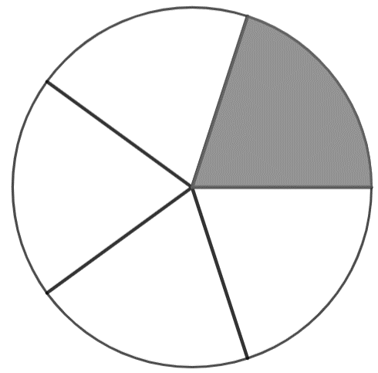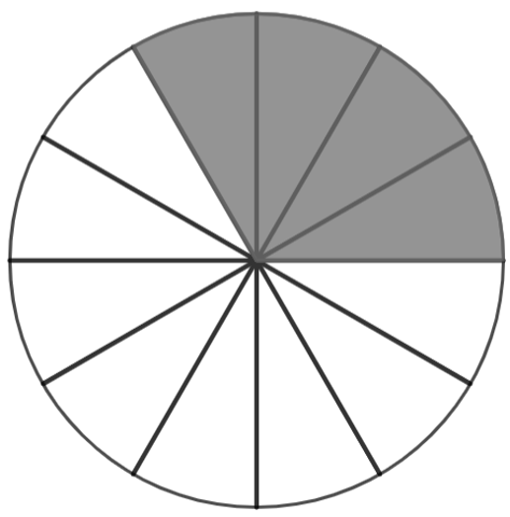

|  |  |  |
| --- | --- | --- |
|  |  |  |

|  |  |  |  |  |  |  |  |  |  |
| --- | --- | --- | --- | --- | --- | --- | --- | --- | --- |
|  |  |  |  |  |  |  |  |  |  |

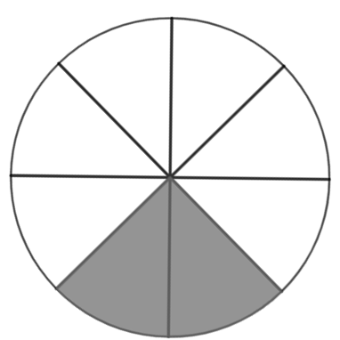 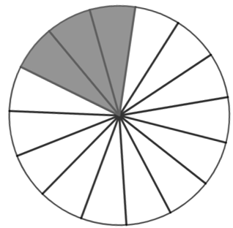

|  |  |  |  |  |  |  |  |  |
| --- | --- | --- | --- | --- | --- | --- | --- | --- |
|  |  |  |  |  |  |  |  |  |

|  |  |  |  |
| --- | --- | --- | --- |
|  |  |  |  |
|  |  |  |  |

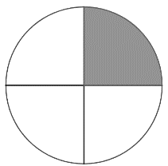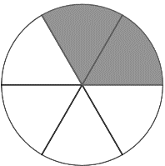

**Gib** die abgebildeten Brüche **an**. **Notiere** die **E**rweiterungs**z**ahl (EZ).

a)

EZ: 2

Multipliziere den Zähler und den Nenner mit 2.

|  |
| --- |
|  |
|  |

|  |  |
| --- | --- |
|  |  |
|  |  |

=

|  |  |  |
| --- | --- | --- |
|  |  |  |
|  |  |  |

b)

EZ: _____

|  |
| --- |
|  |
|  |

$\frac{ · }{ · }$ =

c)

EZ: _____

|  |
| --- |
|  |
|  |
|  |

|  |  |  |  |
| --- | --- | --- | --- |
|  |  |  |  |
|  |  |  |  |
|  |  |  |  |

=

d)

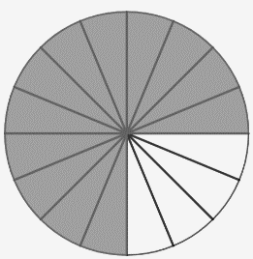 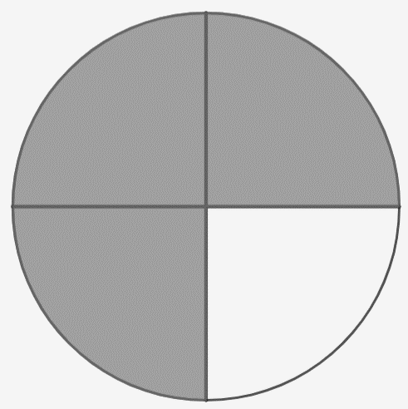

EZ:

$\frac{ · }{ · }$ _____

=

e)

**Weitere Schreibweise**

Bedeutung: Erweitere den Bruch mit 5

|  |  |  |  |
| --- | --- | --- | --- |
|  |  |  |  |

|  |  |  |  |
| --- | --- | --- | --- |
|  |  |  |  |
|  |  |  |  |
|  |  |  |  |
|  |  |  |  |
|  |  |  |  |

5

=

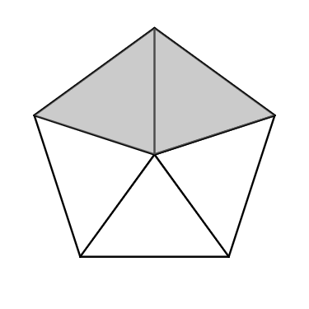f)

EZ: ____

_

=

Der Ausgangsbruch (linkes Bild) und die Erweiterungszahl sind gegeben. Wie sieht der Bruch nach dem Verfeinern/ Erweitern aus? **Zeichne** fertig (rechtes Bild)!

|  |
| --- |
|  |
|  |

|  |
| --- |
|  |
|  |

a)

6

=

|  |
| --- |
|  |
|  |
|  |
|  |

|  |
| --- |
|  |
|  |
|  |
|  |

b)

3

=

|  |
| --- |
|  |
|  |
|  |

|  |
| --- |
|  |
|  |
|  |

c)

5

=

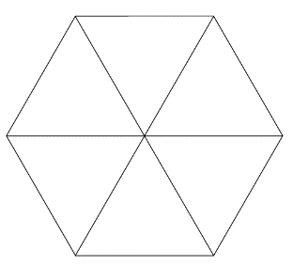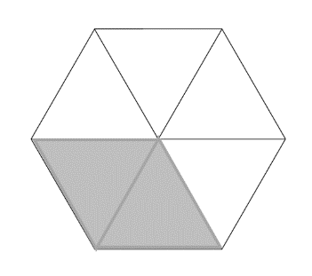d)

2

=